Home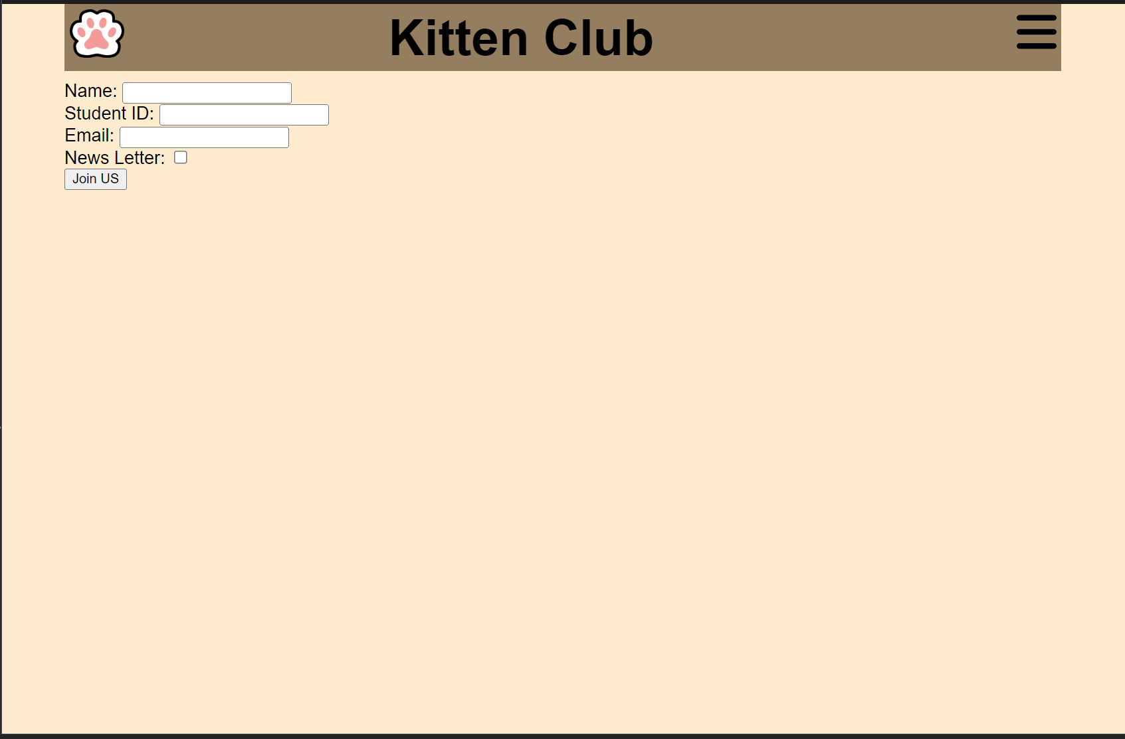

Signup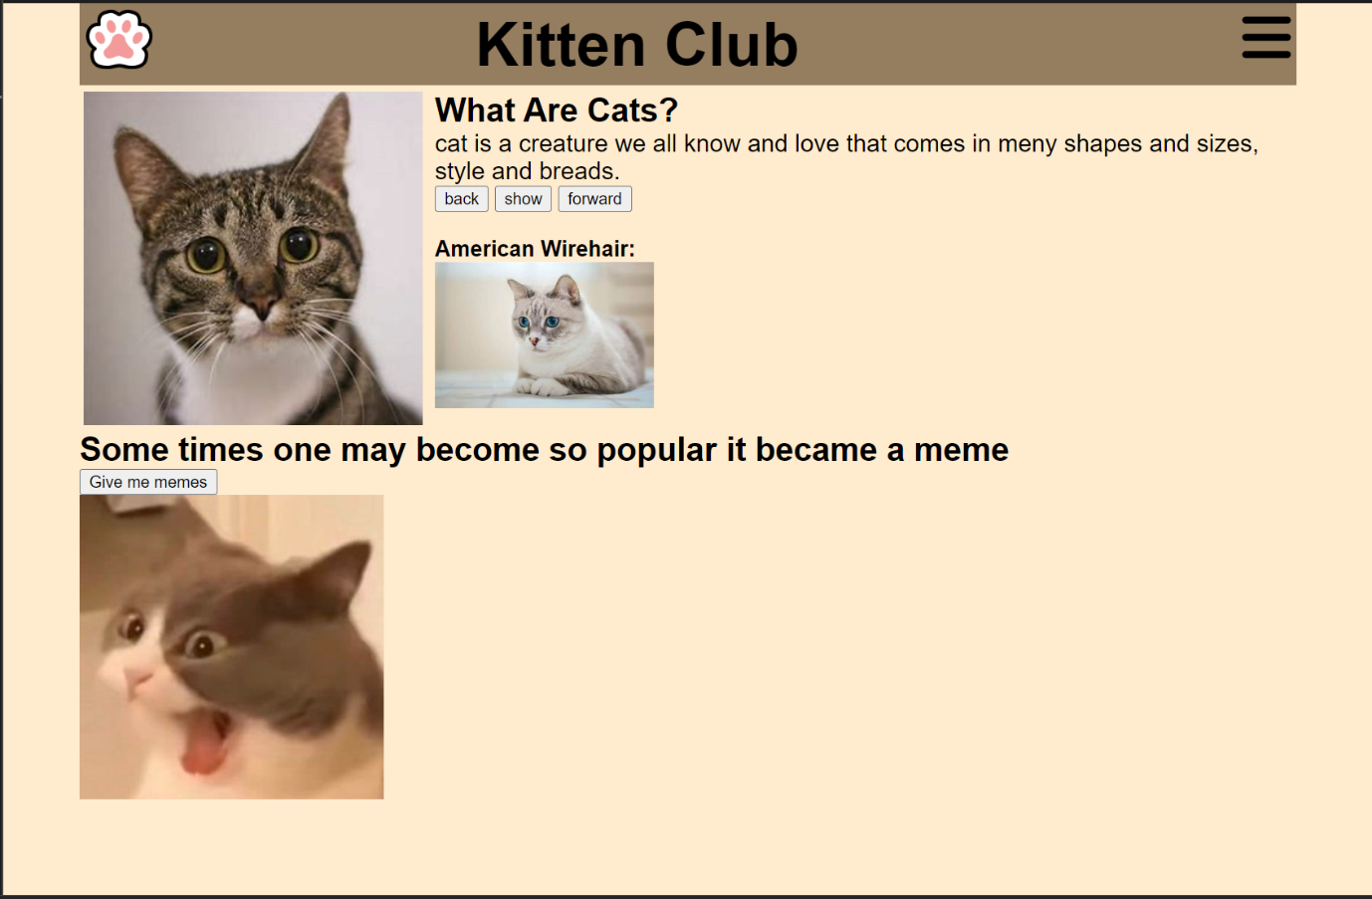

Activity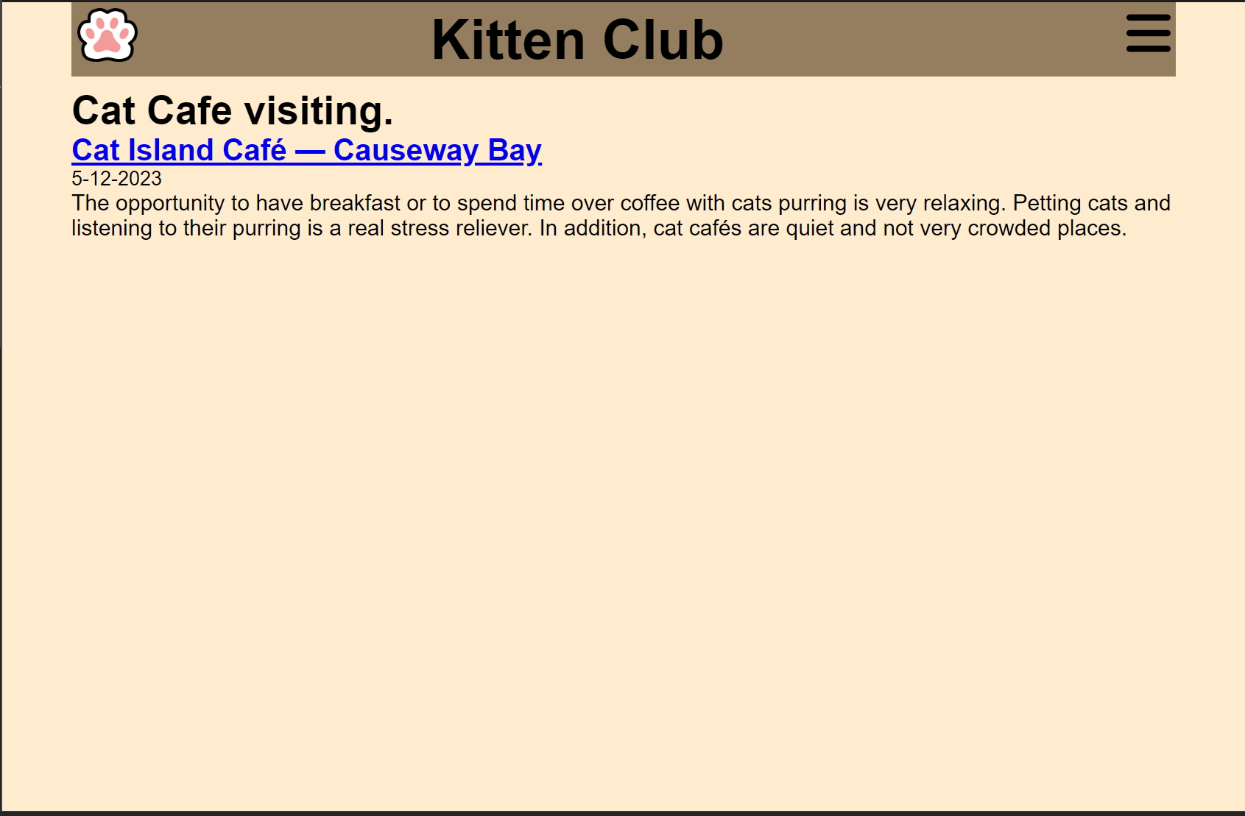

Our design is very simple. Nothing more than a few buttons. Theme color is mostly brown, creating a relaxing atmosphere on the site. After clicking the show meme button, a fine relatable selection of cat memes are displayed one by one, making people just want to scroll through and enjoy each one.

The signup page only contains the signup field, showing the relaxation and effortless nature of joining the club. All you do is play with cats.

Our club doesn't have many activities, only one, because we are still a very young club but as more people join more activities will be popularized.

Our club objective is to help students relax from all the crushing stress that have caused them over the years. With such simple objective. Out club page needs to also be simple. As a bonus when you hover over our logo, it rotates